EXPERIMENT 14: Applying Deep Learning methods for an Application

**Name :** D V Ravi Sridhar

**Reg No. :** RA1811003010732

**Section :** CSE – D2

# Date : 27/04/2021

**Problem Description :-**

**Facial Recognition using Deep Learning**

Face recognition is the problem of identifying and verifying people in a photograph by their face.

It is a task that is trivially performed by humans, even under varying light and when faces are changed by age or obstructed with accessories and facial hair. Nevertheless, it is remained a challenging computer vision problem for decades until recently.

Deep learning methods are able to leverage very large datasets of faces and learn rich and compact representations of faces, allowing modern models to first perform as-well and later to outperform the face recognition capabilities of humans.

**Code :-**

import cv2 import sys

* Get user supplied values imagePath = sys.argv[1]

cascPath = "haarcascade_frontalface_default.xml"

* Create the haar cascade

faceCascade = cv2.CascadeClassifier(cascPath)

* Read the image

image = cv2.imread(imagePath)

gray = cv2.cvtColor(image, cv2.COLOR_BGR2GRAY)

* Detect faces in the image

faces = faceCascade.detectMultiScale( gray,

scaleFactor=1.2, minNeighbors=6, minSize=(10, 10)

#flags = cv2.CV_HAAR_SCALE_IMAGE

)

print("Found {0} faces!".format(len(faces))) # Draw a rectangle around the faces

for (x, y, w, h) in faces:

cv2.rectangle(image, (x, y), (x+w, y+h), (0, 255, 0), 2)

cv2.imshow("Faces found", image) cv2.waitKey(0)

**Screenshot from Output :-**

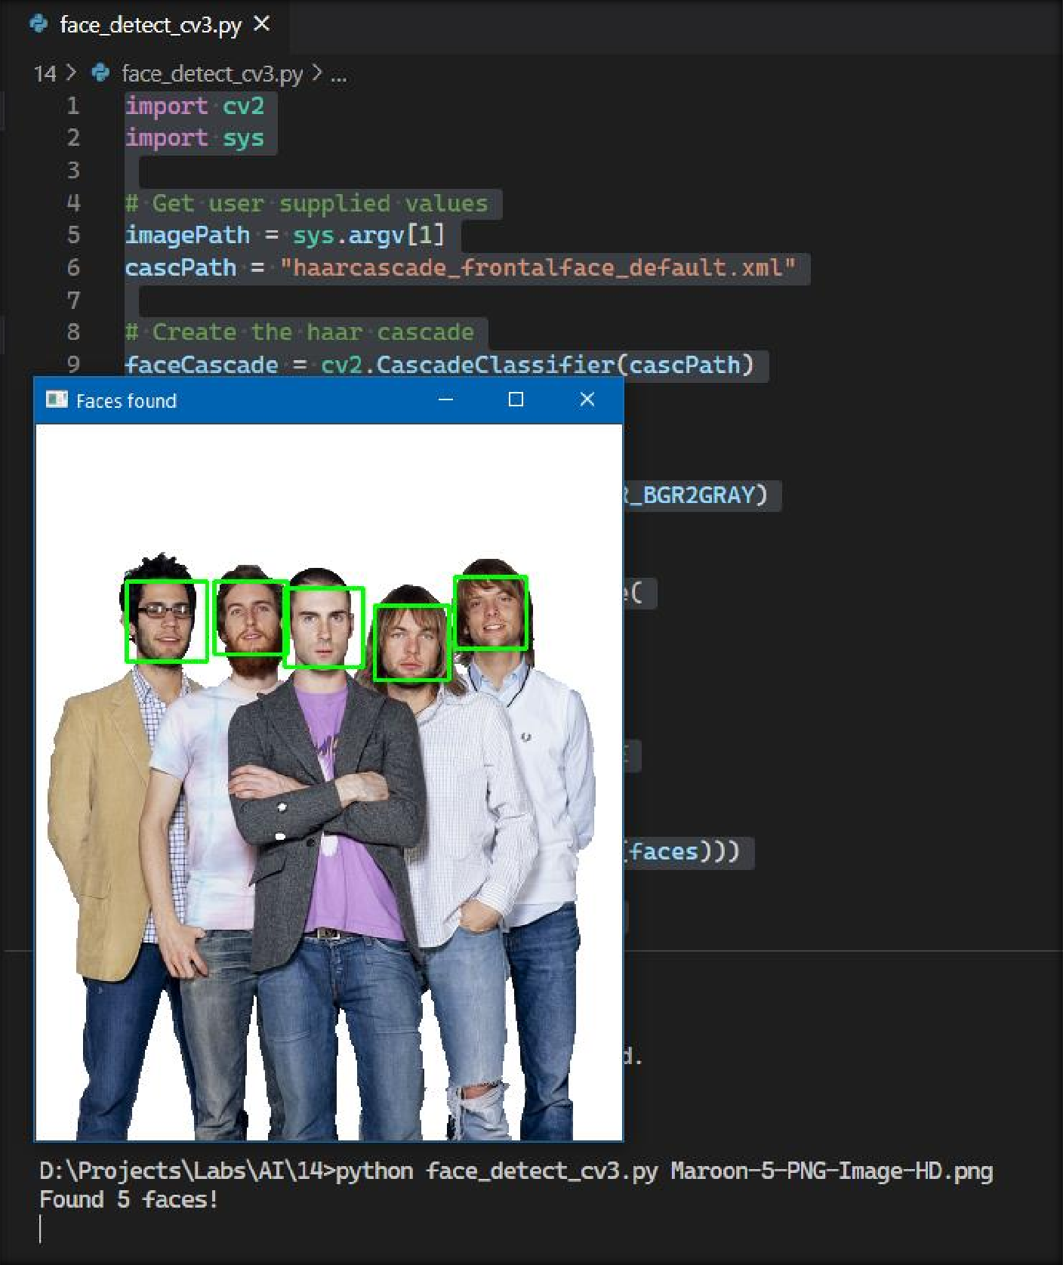

**Result**

The experiment was successfully implemented and executed.